H.T No
Regulations:
A18

Sreenidhi Institute of Science and Technology
(An Autonomous Institution)
Code No: 7HC16 Date: 03-Dec-2020 (FN)

B.Tech II-Year II-Semester External Examination, Nov/Dec - 2020 (Regular)
MATHEMATICS-II (DIFFERENTIAL CALCULUS) (CSE, IT and ECM)

Time: 2 Hours Max.Marks:70

Note: a) No additional answer sheets will be provided.
b) All sub-parts of a question must be answered at one place only, otherwise it will not be valued.
c) Missing data can be assumed suitably.

ANSWER ANY 5 OUT OF 8 QUESTIONS. EACH QUESTION CARRIES 14 MARKS.

1. | a) | Discuss the continuity of the function 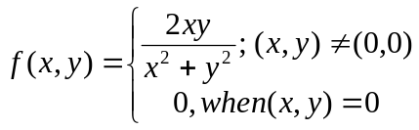 | [7M]
 | b) | Define limit of the function of two variable with atleast one example. | [7M]
2. | a) | 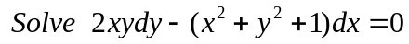 | [7M]
 | b) | A body kept in air with temperature 25ºc cools from 140ºc to 80ºc in 20 minutes. Find when the body cools down to 35ºc. | [7M]
3. | a) | Solve (D²+D+1)y=Sin2x | [7M]
 | b) | Solve (D²-1)y=e^{x}+x² | [7M]
4. | a) | Obtain a root up to three decimal places of the given equation x³-4x-9=0; using the bisection method. | [7M]
 | b) | Explain briefly the significant difference between Bisection method and Newton Raphson method. | [7M]
5. | a) | Determine y(0.1) of y|=x-y² ;y(0)=1 by Taylors series. | [7M]
 | b) | Determine y(0.2) in steps of h=0.1 of y|=1+y² ;y(0)=0 by R-K method. | [7M]
6. | a) | Apply L{t²+sin³t+e^{3t}+1}. | [7M]
 | b) | Apply L⁻¹{s/(s²+1)²} using convolution theorem. | [7M]
7. | a) | Discuss the maxima and minima of f(x,y)=x²y+ xy²-axy . | [7M]
 | b) | Verify the functional relationship between them and show the functional dependency of u=x+y+z;  v=x²+ y²+ z²;  w=x³+y³+z³-3xyz | [7M]
8. | a) | Solve 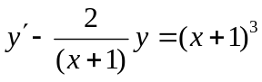 | [7M]
 | b) | Solve y(xy+e^{x})dx- e^{x}dy=0 | [7M]

-- 00 -- 00 –

